The following text is for test items 1 and 2.
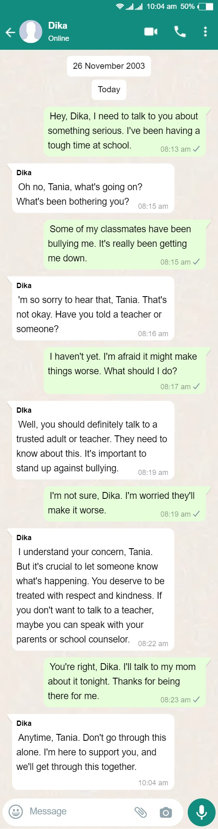

- What is the primary background of the chat?
  - They plan a surprise for a friend.
  - Tania asks Dika for homework help.
  - Dika shares his counseling plan with Tania.
  - Tania confides about being bullied at school.

- How does Tania likely feel after having a chat with Dika about the bullying issue?
  - Relieved and supported.
  - Indifferent and uncaring.
  - Confused and doubtful.
  - Angry and upset.

The following text is for test items 3 and 4

- Where can we probably find such kind of text?
  - In an airport.
  - In a harbour.
  - In a railway station.
  - In a department store.

- Based on the text, we know that the passengers are ….
  - recommended to use baggage trolley in the area
  - allowed to enter the area without showing a passport
  - banned to bring a boarding pass to their next destination
  - permitted to enter the area with the requirements provided

The following text is for test items 5 and 6.

- Which of the following statements are in line with the text?
- There is no prize for the winner in the activity.
- There is a payment if the students want to join the activity.
- The school holiday tennis clinic was conducted in two days.
- The school holiday tennis clinic was conducted for eight hours.

- “Loads of prizes to be won”
The expression means that the readers …
  - must prepare the prizes for the winner of the competition.
  - have to pay some money to get the winner and prizes.
  - will get prizes if they join and win the competition.
  - can get the prizes after paying the registration.

The following text is for test items 7 to 9.
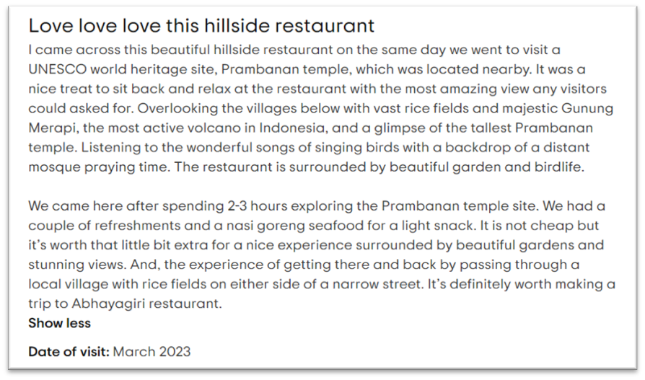
- After reading the text, we know that the writer was … of the restaurant.
  - disappointed
  - contented
  - ashamed
  - terrified

- Decide whether each statement is true or false.
 | Statement | True | False
A | The restaurant is located far from Prambanan temple.
B | The restaurant is only surrounded by the beautiful garden.
C | The food of the restaurant is costly but it’s worth.

- ”… surrounded by beautiful garden and stunning views.”
What is the similar meaning of the underlined word?
  - hazardous
  - gorgeous
  - generous
  - curious

The following text is for test items 10 to 12.
Last month, I got important lesson in my life. It was when I took the first exam. It didn't go well. I told myself, "Tomorrow must be better.” The next day exam was conducted, but it wasn't easy, and I couldn't attempt all the questions. I said to myself, "Let's try the fortune tomorrow." Again I prepared well. I took the next exam, I was happy after the scores were out this time. I thought I'd got a good score, then I asked others, my score wasn't a great score. I studied all night for the exams, but it still didn't go well.
Next day, I had the last exam, I told myself, "Let's try this last time." The last exam was very difficult for everyone. I kept writing the answers until the invigilator call my name to stop writing and start scanning. Five minutes were left, it was a situation where late submissions weren't accepted, and then I hurriedly scanned the pdf of my answers and uploaded it. I just submitted it 12 seconds before the deadline.
On that day, I declared myself "self-discipline is important". What inspires me to do best in my life is that constant belief.

- What does the text tell us about?
  - The writer’s experience on finding self-discipline.
  - The writer’s important thing in his/her life.
  - The writer’s constant belief as a student.
  - The writer’s result after having exams.

- Decide whether each statement is true or false.
 | Statement | True | False
A | The writer studied all night for the exams to get a good score.
B | The writer submitted the scanning 12 second after the deadline.
C | The writer started scanning the pdf after the invigilator called her name.

- What is the main idea of the second paragraph?
  - The writer had the last exam.
  - The writer submitted her last exam.
  - The writer had the first and second exam.
  - The writer declared the important of self-discipline.

The following text is for test items 13 and 14.
How to Use Graphs
When editing with Capcut, you can add graphs to your project to make your new creations more unique. Graphs in Capcut smoothen the shift between “Keyframes” and increase the image quality of your video. However, Graphs aren’t available for clips without “Keyframes” animation effects. Here’s how to add “Keyframes” in your video clip.
1. Open the Capcut app.
2. Tap on “New Project.”
3. Select a video clip you want to edit.
4. Specify a point in the video when you want the zoom effect to begin.
5. Bring up the “Editing Menu” by tapping the video layer.
6. Tap the “Keyframes” symbol.
7. Zoom and pan on the clip to indicate what you want to highlight.
8. Press the “Play” button to see the result.

Then, it is time to incorporate graphs into any video.
1. Open the Capcut app and tap on “New Project.”
2. Select a video clip you want to edit and perform the desired customizations.
3. Insert two “Keyframes.”
4. Transfer your video to the right side of your screen using the second “Keyframe.”
5. Put the video between your “Keyframes.”
6. Bring up the “Graphs” menu.
7. Choose from any of the “Graphs” options.
8. Tap on the “Pencil” symbol to edit it. Alternatively, you can modify your graph effect by clicking on the button after the “None” icon.
9. Play the video.
10. Export the video to your gallery with the “Upload” icon if you like the result.

- What advantage do the readers gain from the text?
  - Learning how to create animated graphs in Capcut.
  - Discovering how to use the Capcut app for basic video editing.
  - Understanding how to add "Keyframes" to enhance their video clips.
  - Gaining insights into using graphs to improve the image quality in Capcut.

- Which of the following statements are in line with the steps to use graphs with Capcut?
  - You can only add "Keyframes" to clips with animation effects.
  - To use graphs, you need to insert two "Keyframes" in your video.
  - After adding "Keyframes," you should export the video to your gallery immediately.
  - "Graphs" smoothen the shift between "Keyframes" and enhance video image quality.

The following text is for test items 15 to 17.
Ads A | Ads B
 | 

- What are the advertisements about?
- Girls’ fashion.
- Kids’ clothing.
- School supplies.
- Children’s shoes.

- Decide whether each statement is true or false.
 | Statement | True | False
A | Both stores offer some discounts for the customers
B | Both stores provide children’s clothing needs.
C | Both stores serve online purchases.

- After reading the text, the readers will most likely ….
- visit both websites of the stores to get more detailed information
- be more interested to visit bigw.com because there is sale
- come to the offline store of BIGW to get casual lady dress
- call Junior Kids to get ask information about the discount
The following text is for test items 18 to 20.

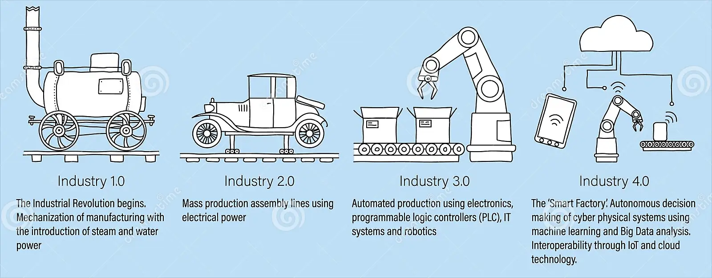

- What is the topic of the following text?
  - The history of the Industrial Revolution.
  - The progress of industrial technologies.
  - The impact of mass production on society.
  - The role of steam power in manufacturing.

- Which of the following statements are in line with the text?
  - The Industrial Revolution began with the introduction of electricity.
  - Industry 3.0 involved the use of electronics and robotics in production.
  - Industry 2.0 focused on steam power for manufacturing.
  - Industry 4.0 is characterized by mass production assembly lines.

- What advantage do the readers gain from this text?
  - Learning about the history of mass production.
  - Discovering the principles of quantum mechanics.
  - Gaining insights into industrial technology development.
  - Understanding the impact of the steam engine on industry.

The following text is for test items 21 to 23.
Once upon a time in a land of trains, there was a little blue engine. The little engine loved to help, but it was very small. One day, the big red engine asked for help to carry toys to the children on the other side of the mountain. The little blue engine wanted to help, but it wasn't sure if it could.
"I'm too small," the little engine said, "I don't know if I can."
But the toys and the big red engine asked nicely, "Please, little blue engine, can you help us?"
The little blue engine thought for a moment, then said, "I'll try!"
And so, the little blue engine started to pull the toys up the steep mountain. Chug, chug, chug, it went. It was tough, but the little blue engine kept saying, "I think I can, I think I can."
And with a final push, the little blue engine reached the top of the mountain. The children cheered, and the little blue engine felt proud.
From that day on, the little blue engine knew that even though it was small, it could do big things if it believed in itself. And it smiled and said, "I thought I could, I thought I could."

- What does the writer want to teach us?
  - The importance of sharing toys with others.
  - The need to always ask for help when facing challenges.
  - The value of believing in ourselves and showing resilience.
  - The significance of being the biggest and strongest person.

- Decide whether each statement is true or false.
 | Statement | True | False
A | The Little Blue Engine helped because it believed it could.
B | The Big Red Engine asked for help because it was too lazy.
C | The Big Red Engine asked for help to deliver toys to the children.

- "Please, little blue engine, can you help us?"
What does the sentence mean?
  - The blue engine refused to help.
  - The red engine ordered the blue engine to help.
  - The red engine asked the blue engine for assistance.
  - The blue engine was too busy to help the red engine.

The following text is for test items 24 and 25.
Eye of the Tiger
Song by Survivor
Rising up, back on the street
Did my time, took my chances
Went the distance, now I'm back on my feet
Just a man and his will to survive
So many times it happens too fast
You change your passion for glory
Don't lose your grip on the dreams of the past
You must fight just to keep them alive
It's the eye of the tiger
It's the thrill of the fight
Rising up to the challenge of our rival
And the last known survivor
Stalks his prey in the night
And he's watching us all with the eye of the tiger
Face to face, out in the heat
Hanging tough, staying hungry
They stack the odds 'til we take to the street
For the kill with the skill to survive

- Decide whether each statement is true or false.
 | Statement | True | False
A | The lyrics encourage resilience and fighting to keep your dreams alive.
B | The singer mentions that they went the distance and are now back on their feet.
C | The singer emphasizes the importance of changing passion for glory.

- "Don't lose your grip on the dreams of the past."
What does it mean?
  - Hold on to your past dreams and never let go.
  - Pursue new dreams and forget about the past.
  - Let go of old dreams to make room for new ones.
  - Forget about your past dreams and focus on the present.

The following text is for test items 26 and 27.
Label A | Label B
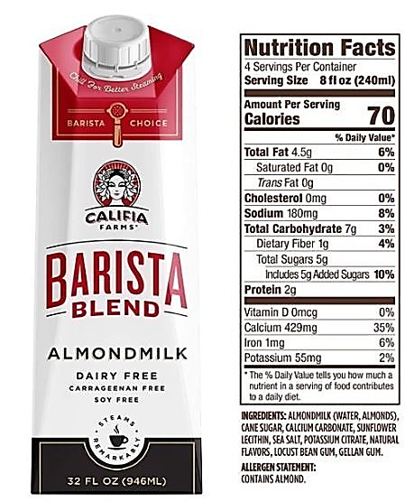 | 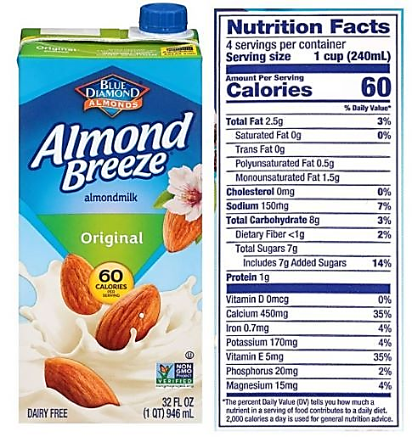

- Which of the following events will probably happen after someone reads the labels?
- A man who needs high calcium will be more interested in product A.
- A mother will buy product A for her baby who is allergic to nuts.
- A man who is allergic to nuts will avoid to buy both products.
- A woman who is in a low-calorie diet will choose product B.

- Decide whether each statement is true or false.
 | Statement | True | False
A | Both products provide high vitamin D.
B | Neither product contain cholesterol.
C | Product B has higher sugar than product A
The following text is for test items 28 to 30.
Web developers are like the architects of the internet. They are the ones who create and build the websites we see and use every day.
Web developers use special codes and programming languages to make websites work. It's a little bit like using magic spells, but instead of waving wands, they type on computers to make everything happen. They decide how a website looks, what buttons do when you click on them, and how fast a page loads.
There are different types of web developers. Some focus on how a website looks, making it pretty and easy to use. They're called "front-end developers." Others work behind the scenes, making sure all the technical stuff works smoothly. They're "back-end developers." Together, they make sure a website is both beautiful and functional.
Web developers are also great problem solvers. If something goes wrong on a website, they figure out how to fix it. It's a bit like being a detective, but instead of solving mysteries, they solve website puzzles. In the world of the internet, web developers are the heroes who bring the web to life, making it a fun and exciting place for all of us to explore.

- By reading the text, the readers will likely ….
- understand the comparison between web developers and architects of the internet
- know the detailed ways of creating websites and making it a fun and interesting read
- appreciate the problem-solving skills of web developers and how they contribute to the internet
- learn about the different types of web developers, such as front-end and back-end developers

- Which of the followings are parts of the writer’s opinion?
- Web developers excel at solving issues and challenges as well.
- Web developers are the champions for giving life to the internet.
- Web developers control a website's appearance and button functions.
- Web developers utilize unique coding to make websites function properly.

- What is the most suitable topic for the next paragraph based on the text?
- The role of front-end developers in website design.
- How web developers learn programming languages.
- The types of problem-solving skills of web developers.
- How web developers use code and programming for websites.

