The following text is for test items 1 – 3.
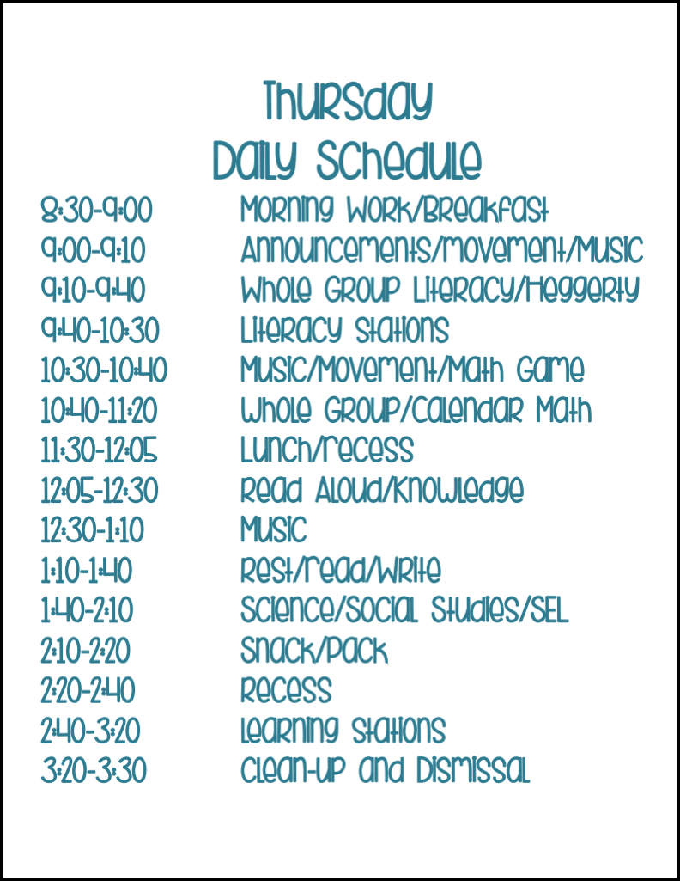
- The schedule shows that students probably need to move their bodies the most during … .
  - Literacy Stations
  - Morning Work / Breakfast
  - Read Aloud / Knowledge
  - Music / Movement / Math Game

- Why is Lunch / Recess placed after Whole Group Calendar Math?
  - Students need rest after learning activities
  - The teacher wants more time for math
  - Students do not like calendar math
  - Students finish school after math

- Decide if the following statements are True or False.
No. | Statement | True | False
 | Students have more than one break on Thursday. | V
 | The last activity of the day is learning stations. |  | V
 | Music activities happen only in the morning. |  | V

The following text is for test items 4 – 6.
Hello! My name is Andin, and I have some study habits that help me with school.
Every day, I usually wake up at 4:30 a.m. I pray and read the material I will study at school that day. After that, I take a shower, eat breakfast, and leave for school at 6 a.m. I ride my bike and usually get to school by 6:30.
After school, I take a shower and eat lunch. Then, I review my class notes and create a mind map that I stick near my study table. This helps me understand the lessons better.
After dinner, I always do my homework and organize my books for the next day's lessons. I also like to make a schedule to keep track of what I need to study.
When I study, I never use my phone so I can stay focused. After I'm done studying, I sometimes take a break and play a mobile game for about 30 minutes.
- Andin’s habits show that she is a student who is … .
  - careless about school
  - bored with daily routines
  - dependent on her friends
  - well-prepared for her study

- What does Andin usually do right after doing her homework?
  - Prepare the books for the next day’s lesson.
  - Read her class notes and make a mind map.
  - Take a rest and play a mobile game for about 30 minutes.
  - Make a schedule to keep track of what she needs to study.

- Why does Andin always make a mind map when reviewing her class notes?
  - To have it stuck near her study table.
  - To keep track of her lessons better.
  - To understand her lessons well.
  - To stay focused on her lessons.

The following text is for test items 7 – 9.
This is Lily’s schedule for Saturday.
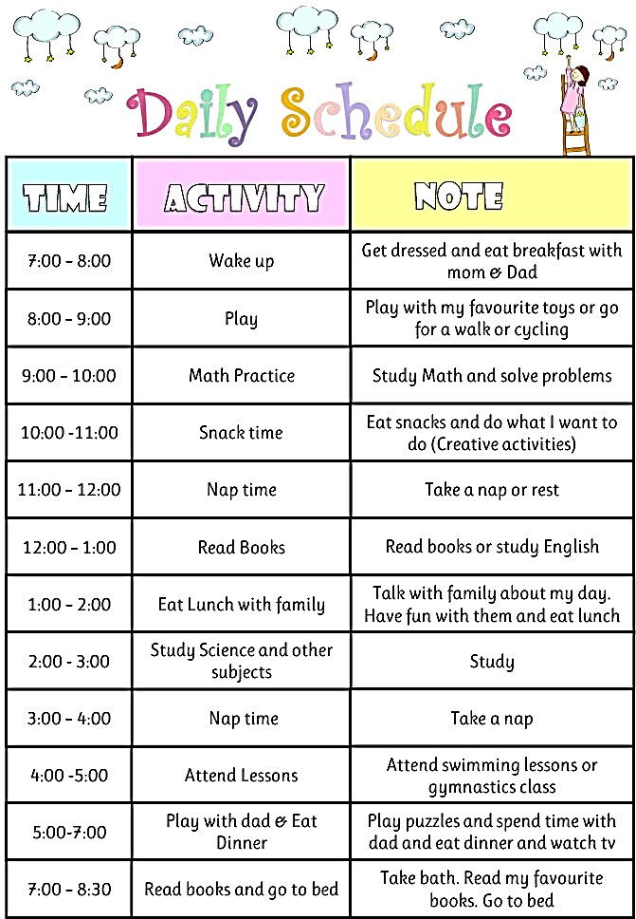

- Lily wrote the text to ….
  - tell her parents about her activities
  - remind her when she can sleep
  - help her manage her time
  - shorten her study time

- From Lily’s schedule, we can conclude that she …
  - studies only in the morning
  - dislikes studying at home
  - balances study and rest
  - prefers playing all day

- Why is Lily’s nap time important for her daily activities?
  - It helps her feel fresh to study again
  - It makes her sleep at night longer
  - It replaces her night sleep
  - It shortens her study time

The following text is for test items 10 – 12.


- Where do you probably find the announcement?
  - In a magazine.
  - In a diary book.
  - In a newspaper.
  - In a social media.

- Why must participants register online before joining the event?
  - Because on-the-spot registration is free
  - Because the place is very small
  - Because registration is limited
  - Because the event is online

- State whether the following statements are True or False.
No. | Statement | True | False
 | People must register online before September 10 to join the auditions. | V
 | Participants can choose which day they want to perform. | V
 | Registration is possible by phone or in person. |  | V

The following text is for test items 13 – 15.

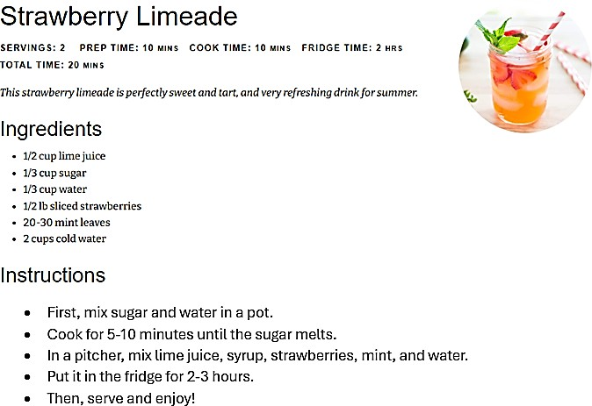
- What will likely happen if the sugar is not boiled with water first?
  - The drink will taste sweeter
  - The sugar will not mix well
  - The drink will look fresher
  - The strawberries will melt
- What do we need to make 4 servings of the drink?
  - 2 cups cold water
  - 1 cup lime juice
  - 1/3 cup water
  - 1/3 cup sugar

- Which step should NOT be changed to keep the drink taste correct?
  - Cooling the drink
  - Boiling the lime juice
  - Mixing all ingredients
  - Serving it immediately

The following text is for test items 16 – 18.

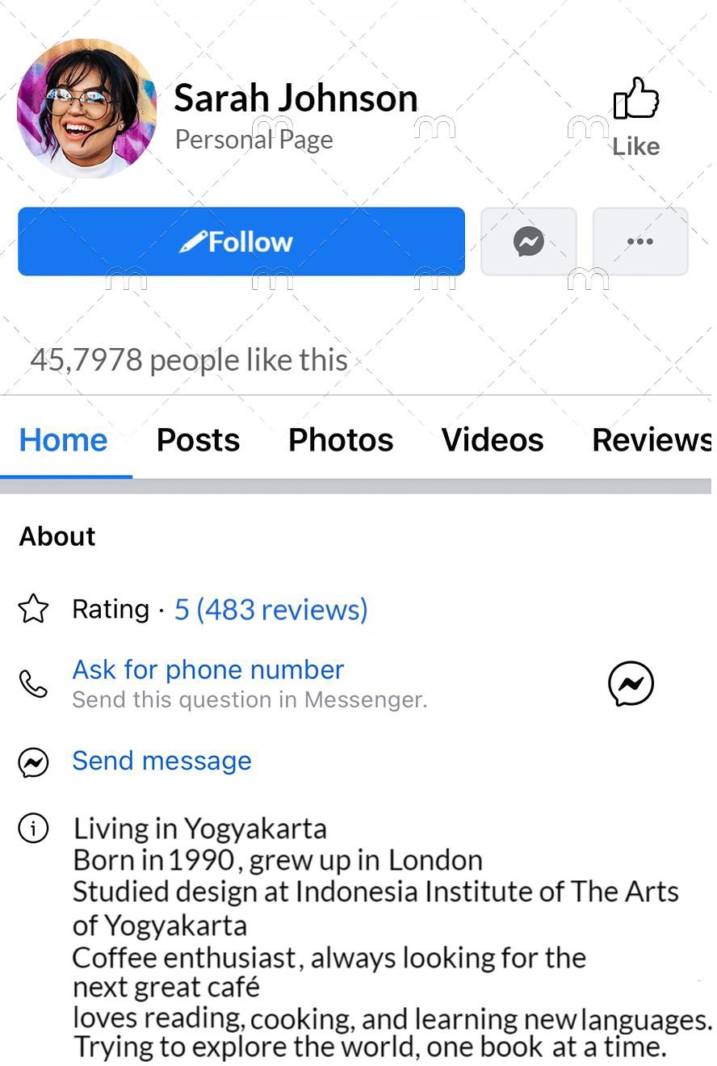
- Sarah’s profile shows that she is someone who …
  - enjoys learning and exploring
  - avoids social interaction
  - dislikes coffee culture
  - focuses only on work

- Which of the following statements is true based of the profile?
  - She is eager to learn new languages.
  - She joined Facebook in 1990.
  - She was born in Yogyakarta.
  - She is a coffee shop owner.

- After reading the profile, a coffee enthusiast will probably …
- Message Sarah to recommend cafés in Jakarta
- Ask Sarah about learning new language tips.
- Follow Sarah to get more info about books.
- Follow Sarah to discover new cafés.

The following text is for test items 19 – 21.
Count on Me Bruno Mars
If you ever find yourself stuck in the middle of the sea
I'll sail the world to find you
If you ever find yourself lost in the dark and you can't see
I'll be the light to guide you
We'll find out what we're made of
When we are called to help our friends in need

You can count on me like one, two, three
I'll be there
And I know when I need it, I can count on you like four, three, two And you'll be there
'Cause that's what friends are supposed to do, oh, yeah Ooh-ooh-ooh-ooh

- The writer of the song is probably ….
  - a true friend who is always helpful
  - a stranger giving advice to others
  - a friend who is dependent to us
  - a parent helping their children

- The song shows that true friendship means ….
  - helping each other in need
  - always being together
  - giving expensive gifts
  - meeting every day

- What is the moral message of the song?
- Friends should always have fun together.
- True friendship means supporting each other.
- You should make as many friends as possible.
- Good friends are always ready to help one another.

The following text is for test items 22 – 24.
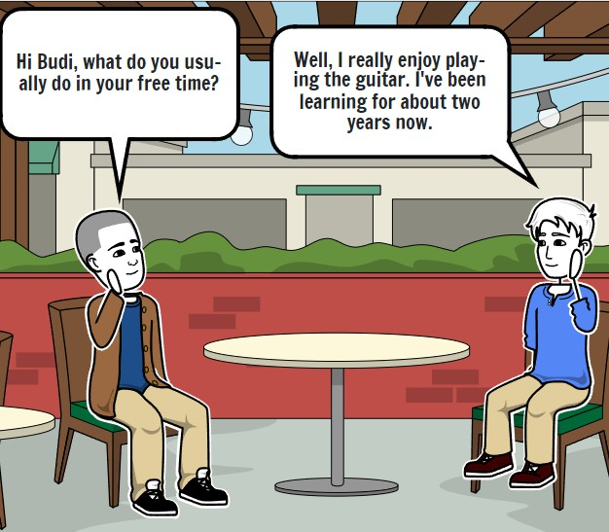 | 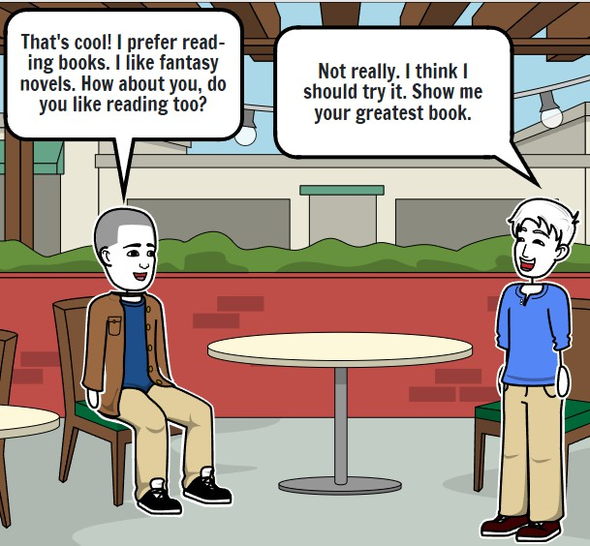

- Which of the followings is in line with the text?
  - Andi is interested in playing guitar.
  - Andi dislikes reading fictional books.
  - Budi and Andi have the same hobby.
  - Budi is curious about Andi’s greatest book.

- What will Budi and Andi probably do after having the conversation?
  - Go to Andi's house to read the book.
  - Continue discussing their hobbies.
  - Learn to play a guitar together.
  - Join a reading club.

- Decide if the following statements are True or False.
No. | Statement | True | False
 | Budi is interested in trying Andi's hobby even though they have different interests. | v
 | Andi has just started learning to play the guitar a few days ago. |  | V
 | Both Budi and Andi are planning to do an activity together after their talk. | v

The following text is for test items 25 – 27.
My Junior High School
My junior high school is one of the best in town. It’s close to my house, and I usually ride my bike there. It takes me about 10-15 minutes to get to school.
The school is really big, covering about 4 hectares, and it's surrounded by tall fences. There are 21 classrooms, a large teacher's room, the principal's office, 21 bathrooms, an auditorium, a library, two science labs, three computer labs, a football field, a basketball court, a mosque, a health clinic (UKS), five canteens, and a big parking lot for teachers, students, and visitors. All the buildings are arranged in a rectangle, with a field in the middle, which we use for sports and school ceremonies.
When you enter the school through the gate, the first thing you see is the security post. Two security guards are always there to keep the school safe. Next to the security post is a large fish pond, which makes the school look even more beautiful. After passing the parking area, you’ll see the main building. It’s big and is where the teachers, the principal, and other staff have their offices.
Further in, you’ll reach the classroom buildings. On the right, there are 7 classrooms for the 7th grade, 7 for the 9th grade, 8 bathrooms, the science labs, the UKS, and the library. On the left, there are 7 classrooms for the 8th grade, more bathrooms, the auditorium, a computer lab, and the mosque. The canteens are behind the auditorium.
In front of each classroom, there are small flower gardens where students like to hang out and sometimes study. There are also lots of big trees, which make the air feel fresh and clean around the school. My favorite place is the fish pond. During breaks, I love sitting by the pond and watching the fish swim—it helps me relax and get inspired.
- Which following statement are in line with the text?
- The writer’s school is spacious.
- There is a swimming pool in the writer’s school.
- The canteen is located in front of the auditorium and behind the mosque.
- There are headmaster and staffs’ room in the main building of the writer’s school.

- How many rooms are there on the right side of classroom building?
  - 26
  - 25
  - 14
  - 22

- What benefit will the readers get after reading the text?
  - Get detailed description about the writer’s school.
  - Get general description about the writer’s school.
  - Know the description of the writers’ teacher.
  - Know about the writer activities at school.

The following text is for test items 28 – 30.
My home is small, but full of light,
With windows big and shining bright.
The walls are white, the roof is high,
I feel so safe as time goes by.

I have my bed, my cozy chair,
My toys and books are everywhere.
I sleep, I play, I laugh, I sing,
My home is where I do everything.
In the kitchen, mom cooks with care,
I smell the food and wait to share.
Dad reads a book or watches TV,
We sit together, just us three.

In my home, I feel so free,
With love and smiles surrounding me.
No place on earth I’d rather be,
My home is perfect just for me.

- The poem will likely be read in a/an … event at school.
  - birthday
  - graduation
  - parent’s day
  - examination

- From the third stanza we can conclude that …
- The writer’s mom is a caring lady.
- The writer has such a loving family.
- The writer’s father cannot cook at all.
- The writer doesn’t like spending time at home.
- After reading the poem, the parents of the writer may feel ….
  - angry
  - jealous
  - grateful
  - confuse

